E-COMMERCE ORDER MANAGEMENT DATABASE SYSTEM

WEEK 3: SELLER AND INVENTORY MANAGEMENT SYSTEM

SAMPLE SELLER & INVENTORY DATA

1. Seller Records
The Seller table contains the seller details used to manage different sellers or suppliers in the E-Commerce Order Management Database System. Ten seller records are included for demonstrating seller information and database operations.
S.No | Seller_ID | Seller_Name | Email | Phone | Address
1 | S101 | ABC Electronics | abc@gmail.com | 9876543210 | Chennai
2 | S102 | Fashion World | fashion@gmail.com | 9876543211 | Madurai
3 | S103 | Tech Store | tech@gmail.com | 9876543212 | Coimbatore
4 | S104 | Home Needs | home@gmail.com | 9876543213 | Trichy
5 | S105 | Smart Gadgets | smart@gmail.com | 9876543214 | Salem
6 | S106 | Book House | book@gmail.com | 9876543215 | Chennai
7 | S107 | Shoe Mart | shoe@gmail.com | 9876543216 | Madurai
8 | S108 | Kitchen World | kitchen@gmail.com | 9876543217 | Tirunelveli
9 | S109 | Mobile Hub | mobile@gmail.com | 9876543218 | Coimbatore
10 | S110 | Daily Needs | daily@gmail.com | 9876543219 | Thoothukudi

2. Inventory Records
The Inventory table contains sample stock information along with the seller and product to which each inventory record belongs. The records include product ID, seller ID, stock quantity, stock status, and last updated date.
S.No | Inventory_ID | Product_  ID | Seller_  ID | Stock_Quantity | Stock_  Status | Last_  Updated
1 | 1 | 1 | S101 | 25 | Available | 2026-09-15
2 | 2 | 2 | S102 | 15 | Available | 2026-09-15
3 | 3 | 3 | S103 | 0 | Out of Stock | 2026-09-15
4 | 4 | 4 | S104 | 8 | Available | 2026-09-15
5 | 5 | 5 | S105 | 30 | Available | 2026-09-15
6 | 6 | 6 | S106 | 5 | Available | 2026-09-15
7 | 7 | 7 | S107 | 0 | Out of Stock | 2026-09-15
8 | 8 | 8 | S108 | 18 | Available | 2026-09-15
9 | 9 | 9 | S109 | 12 | Available | 2026-09-15
10 | 10 | 10 | S110 | 40 | Available | 2026-09-15

3. Sample Data Verification
The Seller and Inventory records are displayed using SELECT operations to verify that the sample data has been inserted correctly into the database.
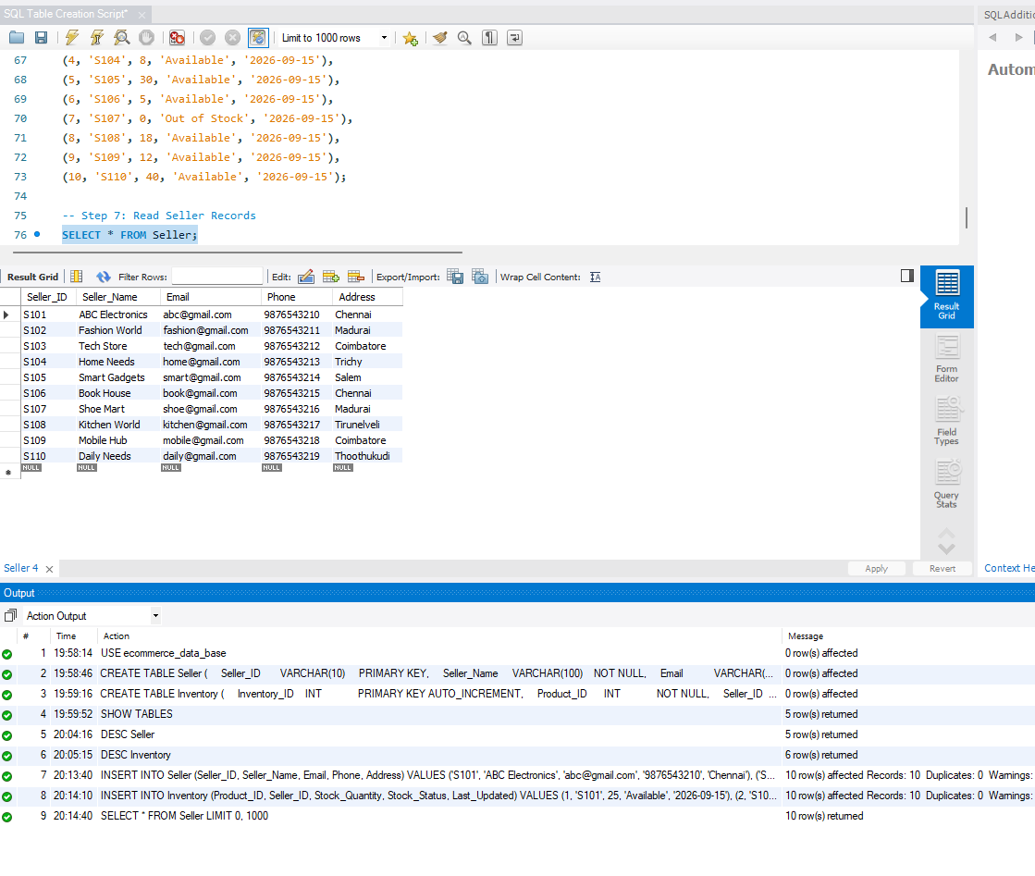

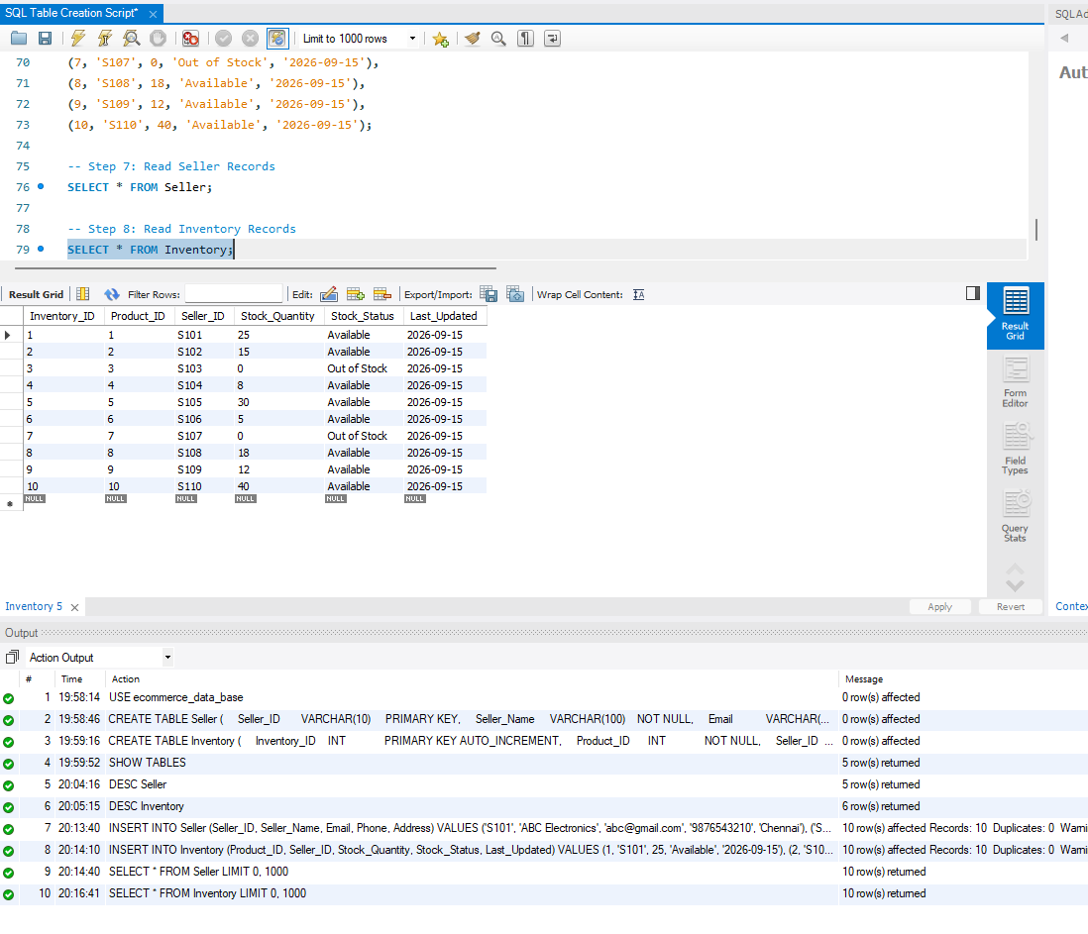

4. Sample Data Description
The sample data contains 10 seller records and 10 inventory records. Each inventory record is associated with a product through Product_ID and with a seller through Seller_ID. The records demonstrate different stock quantities and both Available and Out of Stock conditions.

5. Conclusion
The sample data provides the required seller and inventory records for the Seller and Inventory Management System. The records include seller details, product-seller relationships, stock quantities, stock status, and update dates. The data is suitable for performing CRUD operations and inventory management analysis.

